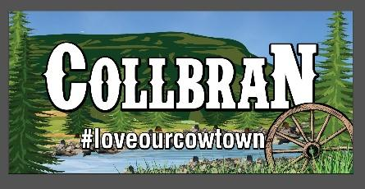

Plateau Valley Heritage Days Parade
July 4th - Report to PE Road behind JobCorps @ 9:30am

Contact Info:
Name:__________________________________________
Phone:__________________________________________
Email:___________________________________________

Description of Entry:
____________________________________________________________________________________________________________

Introduction for the Announcer to read at the parade:
______________________________________________________________________________________________________________________________________________________________________________________________________________________________________________________________________________________________________________________________

For more information, please contact Melonie or Jenni at (970)487-3751
Please return your entry form to Collbran Town Hall or email it to admin@townofcollbran.us by July 2nd.

