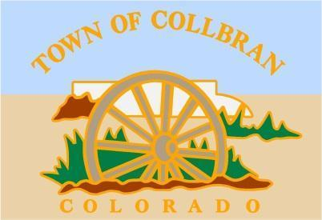

**Town of Collbran**

**1010 High Street Phone: 970-487-3751**

**PO Box 387 Fax: 970-487-3380**

**Collbran, CO 81624**

September 15, 2023

Dear Collbran Community Organization:

As part of the 2024 budget, the Town is asking that community organizations make funding requests during our budgeting review. In this way, the Board of Trustees can decide on funding as part of the overall review of funds available for the fiscal year 2024. This procedure permits organizations to make requests and allows you to plan your finances for your 2024 fiscal year as well.

Enclosed, please find the Collbran Discretionary Fund Application form. Please submit your request by the **4:00 pm deadline on** **October 6th,** so the Trustees can make a funding decision prior to adoption of their 2024 budget.

Sincerely,

Melonie Matarozzo

Town Administrator