Collbran Community Yard Sale
Welcome to Collbran! We are so excited to host you in our beautiful town. Please enjoy the following Yard Sale locations.
Downtown Sale Locations
- 1008 Elm Ave
- 312 Putney Ave
- 413 Spring St
- Gandi Park – 5800 Peninsula Rd
(multi-family selling site)

Surrounding Areas Sale Locations
- 57704 Hwy 330, Space 23
- 15616 57 ½ Rd **ESTATE SALE**
- 14800 N Ouray Ct
- 59512 ME Rd
*Please refer to your maps or navigation apps for the above addresses in red.*
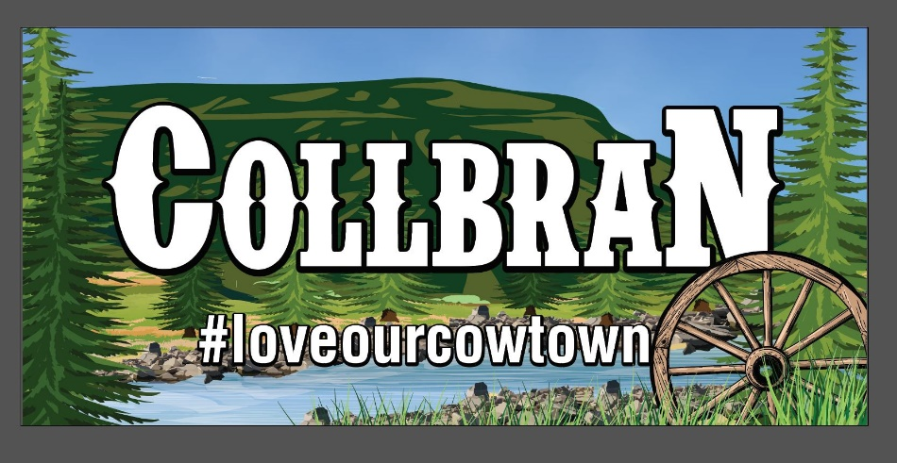

Thank you for joining us.
Come Back and Visit Again Soon!

